FAKIR MOHAN PATRA  DOB: 28th JUNE 1986  Mob: +91-9439464712  e-mail:fakirmohanpatra08@gmail.com | MAILING ADDRESS: -  c/o; Radha mohan patra.  At/po;Baladiabandha  Dist; Dhenkanal | 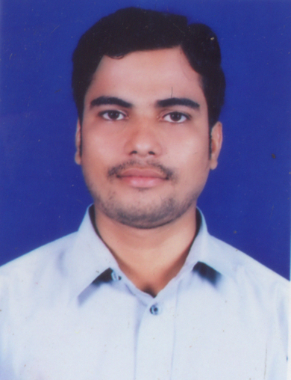

Objective

To work in a challenging position in a growth oriented organization preferably in Healthcare sector & Pharmaceutical Company where my knowledge and expertise will be fully utilized and which will provide me opportunities for career growth.

Educational Qualification

Exam. | Board/ University | Pass out Year | % Of marks
DIPLOMA IN PHARMACY | ODISHA STATE BOARD OF PHARMACY, ODISHA | 2008 | 72.00
+2 SC. | COUNCIL OF HIGHER SECONDARY EDUCATION, ODISHA | 2005 | 42.00
H.S.C | BOARD OF SECONDARY EDUCATION, ODISHA | 2003 | 37.00

Other Qualification

- Post graduate diploma in computer application (PGDCA) From omm maa computer academy, dhenkanal in January 2003

Medical training

- Three months practical training in odapada PHC ,Dhenkanal

- CME Training program on anesthesia.

Work Experience

- One year experience as O.T. pharmacist in Cuttack nurshing home pvt. Ltd., cuttack.[2008 -2009] Well aquanted with
Patient intubations, extubation, anesthesia drugs preparation, , sterilization, O.T. Management

- one year experience as ward pharmacist in Aswini hospital., cuttack.[2009 -2010]

- Now working as a pharmacist in PCCH, telengapenth cuttack (A UNIT OF HEALTH CARE GLOBAL) [ 2010 –till now] with patient management , pre and post operative patient care, chemotherapy transfusion and care taking of radiotherapy patient.

Personal Details

Gender | Male
Languages Known | English, Hindi, Odia
Nationality | Indian
Marital Status | unmarried
Date of birth |  | 28th June 1986
Fathers name |  | Radha mohan patra
Mothers name |  | Jyoshna kumari patra
Permanent address |  | c/o; Radha mohan patra.  At/po; Baladiabandha  Dist; Dhenkanal  Pin-759003
Mobile number |  | +91-9439464712

Strengths

- Acquired practical knowledge through various trainings and real time works.
- An effective communicator with excellent interpersonal & relationship building skills.
- Strong analytical, problem solving & organizational abilities.
- Keen learner with constant zest to acquire new skills.

DATE:
PLACE: Cuttack Fakir Mohan Patra

